# Multi Lingual Developers guide

If you found any wrong in words in your native language. Please correct it’s yourself because we are not Linguists. We are not expert in all languages.

* Open your native language file Resource -> Res.<your>.resx  
  Example:   
  **Res.fr.resx** <= it’s for French language file   
  **Res.ar.resx** <= it’s for Arabic language file

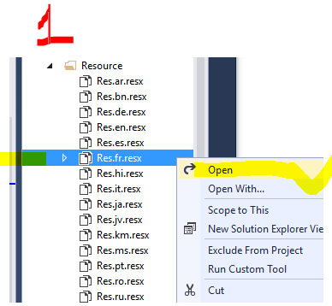

Value column is your native language word (If you found any wrong in words Please correct it yourself)

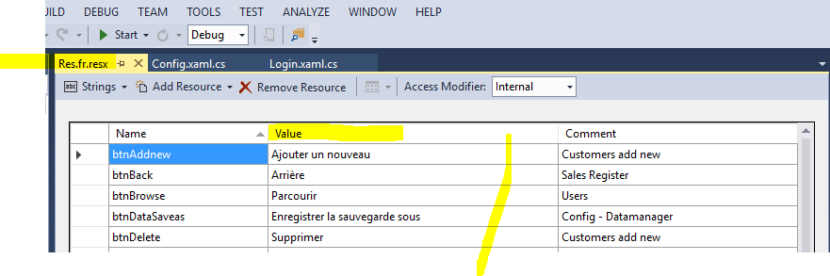

## How to add new resource file for your native language

If you don’t find your language you can add your language resource file

1. Copy Res file and paste to **Resource** folder

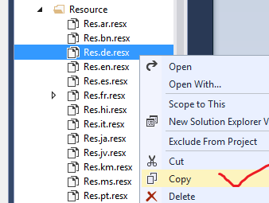

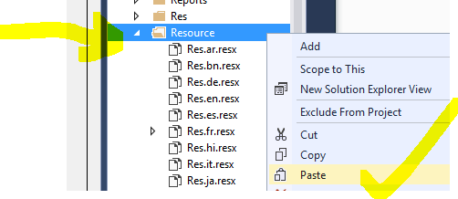

1. Rename your resource file name Res.<languagecode>.resx   
   Example: Res.**cs**.resx it for **Czech**

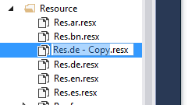

1. Change value column   
   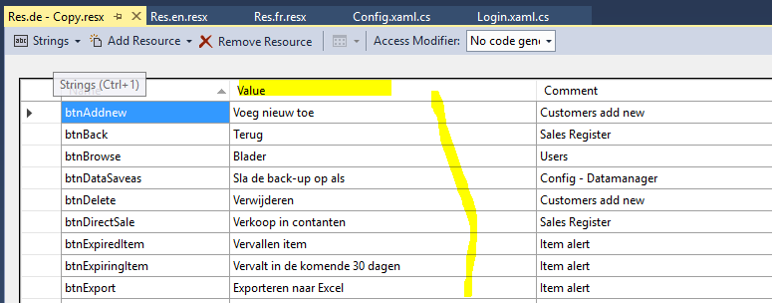
2. Add your language code into Config.xaml file with Design mode after line 89   
   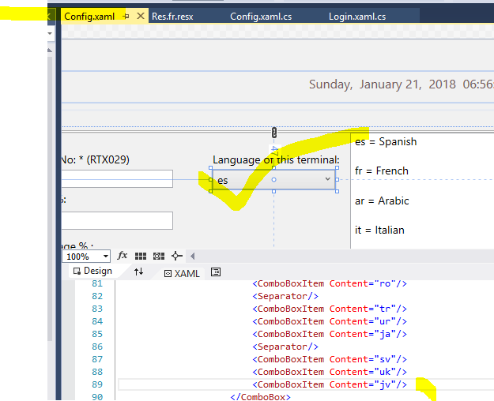  
    Example: <ComboBoxItem Content="cs"/>
3. Now Debug and Run -> Open Setting window and   
   - > select your terminal and   
   -> set your terminal language  
     
   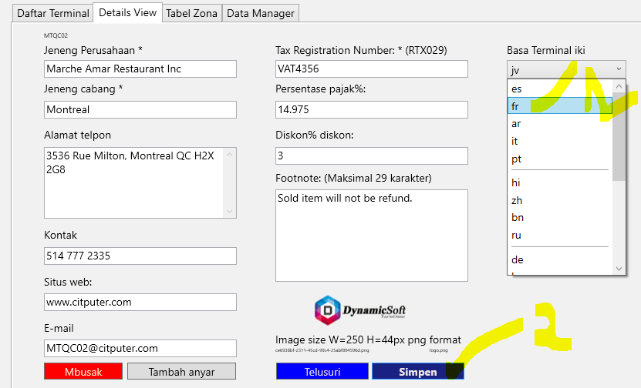

# How to Support SQL server Database to your Native language

Open your SQL Database -> Select RestPOS DB -> Right click -> Select a page as **Options** tab

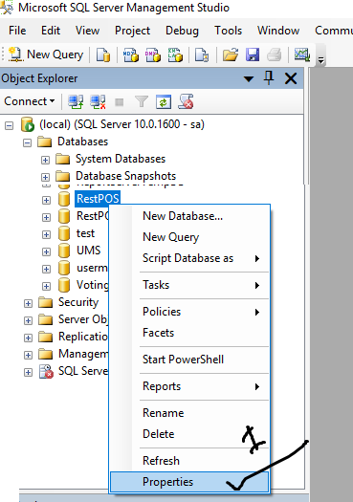

Select **Collation** to your native language -> and Press OK  
Example: For Arabic language: **Arabic_CI_AS_KS_WS**

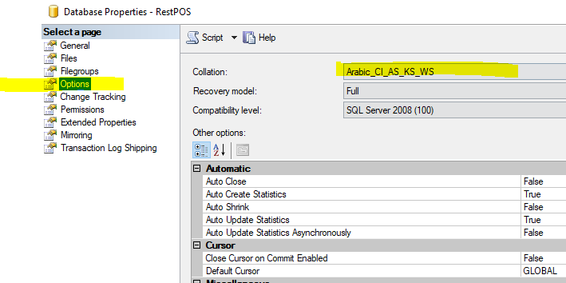

Read more -> [how to Setup Database script into SQL Server](../DatabaseScript/How%20to%20import%20Database%20Script%20into%20SQL%20Server.docx)

**N: B** some pages, label are not able to translate to native language. As like kitchen display those kind of translation you can edit from .xaml design page by editing Label text. Text=””

Numeric value and decimal does not support to native language.  
As for example in English **14.89** it’s translate to 14**,**89 but you have to use as like as English format.

In French, pt, it, ru use 14,89 but u should use 14.89 (decimal value, **not comma**)

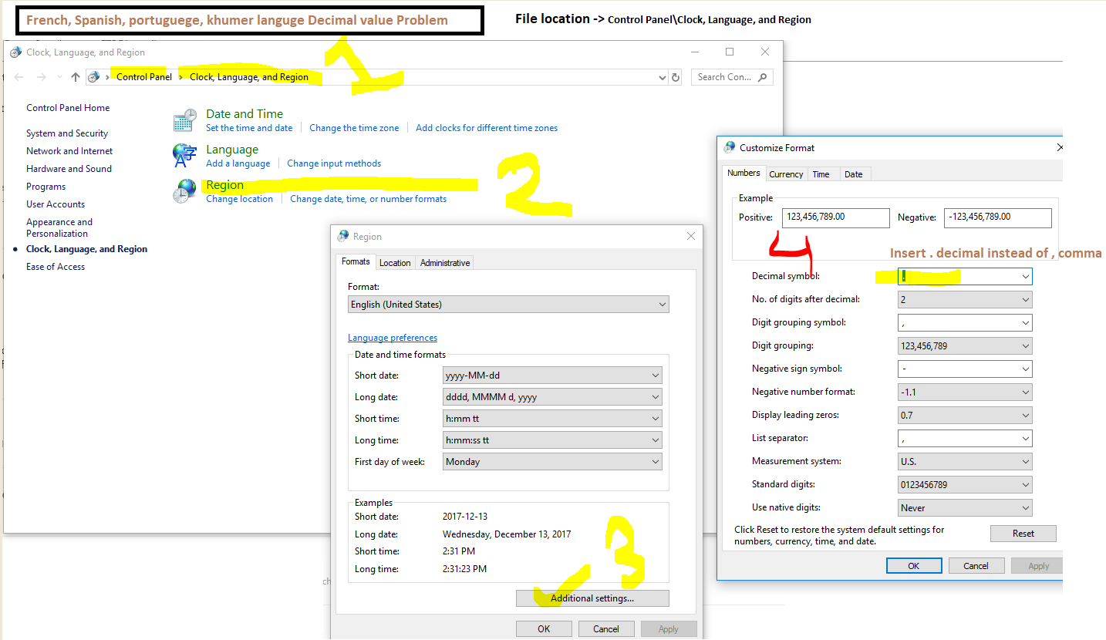If your PC OS language is you native language

Thanks.

**DynamicSoft**

Please don’t forget to Rate us to get Support <http://codecanyon.net/downloads>